CAREER PROGRAMMING
RESOURCE GUIDE

For Club, Group, and
Women of Dartmouth Leaders

Professional Development Committee, Dartmouth Alumni Council
Dartmouth College Office of Alumni Relations

CAREER PROGRAMMING RESOURCE GUIDE

One of Dartmouth’s greatest assets is the strength of the Big Green community. Did you know Dartmouth’s online Career Network has more than 23,000 members? Many job offers and career opportunities are the direct result of connections made through our alumni network.

Alumni interest in career assistance and programming is very high across all demographics. More than half of all alumni and three-quarters of recent graduates are interested in meeting other alumni professionally and using an updated online directory to connect with other alumni.

Dartmouth’s regional alumni clubs, affiliated and shared-interest groups, and Women of Dartmouth communities are well-positioned to help alumni around the girdled earth.

This guide provides resources to help plan a successful career-related program, including data on alumni interest, ideas for career-related events, and best practices for organizing events and suggestions for advertising programs.

When planning your programs, please also refer to the Alumni Career Programming Checklist, Career Resources for Alumni, and other general event planning resources available on our website.

What do Dartmouth alumni want?
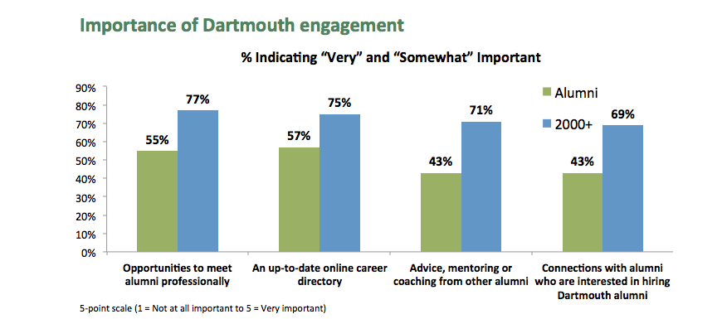
Recent surveys have highlighted strong interest in alumni networking opportunities, as well as other kinds of career programming touching on everything from strategies for career change to work/life balance issues. Results from the August 2014 Moosilauke Forum survey highlight an especially strong interest in virtually every type of career programming among alumni who have graduated since 2000:

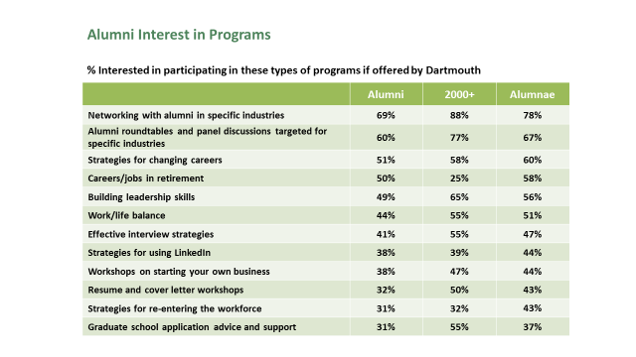
In-person networking events have a very strong appeal to alumni of all ages, with almost 70 percent of alumni in the results above indicating an interest in industry-specific events.
All programming offered should allow alumni ample time for socializing as alumni-to-alumni contact is a primary driver of interest and attendance.
POTENTIAL PROGRAM OFFERINGS

Consider the following best practices for determining optimal career program formats as well as designing and executing events to meet these interests.

Know what career resources are available to alumni
As you begin planning events and programs for your constituents, you’ll want to refer to the online Career Resources for Alumni, the Alumni Career Programming Checklist, and other event-planning resources found online.

Know your organization’s demographics and interests
What works in Washington D.C. doesn’t necessarily work in the Bay Area. What are the dominant industry sectors your region? How are your alumni distributed geographically? What are the particular interests and concerns of your constituents? If you are new to your role within the organization, seek advice from established leaders and program organizers, as well as the insight of the Office of Alumni Relations. Some organizations conduct periodic surveys to generate program ideas.

Know your membership
Surveys of Dartmouth alumni conducted in 2012 and 2014 tell us that young alumni are very interested in connecting with experienced alumni who might be able to offer both advice and hiring opportunities. Past surveys also tell us more experienced alumni might favor industry-specific gatherings. A one-size career program does not necessarily fit all needs, and your group might consider smaller and more targeted events for different audiences.

Tap into your area’s resources
In many cities, potential speakers are willing to share their expertise with your club or group in exchange for visibility and the opportunity to showcase their services. Surveys can help identify alumni who have expertise to share. In other cases, local professional networks can provide a list of potential speakers. Guidelines for educating these individuals on your club or group’s needs and interests are provided in the Appendix of this document.

Choose a program format that meets your goals:
On the following pages, we have listed three sample formats that can be adapted for your events: panel programs, featured speaker events, and speed networking events.

- PANEL PROGRAMS
Ideal application: Alumni events that are over 90 minutes in length. Panels can run from 45 to 75 minutes depending on the nature and appeal of the featured topic. Panels should be timed to allow attendees time to network informally with fellow alumni before or after the panel.

Recommended: Designate a moderator and no more than five panelists who represent diverse backgrounds, opinions, or industry sectors; 3-4 panelists is optimal. Be sure to allow time for questions and answers afterward.

Pros: Panel programs can provide great forums for discussions on trends, current events, and education—they can also stimulate discussion for alumni networking and club or group dialogue.

Cons: If your panel topic is too narrow in scope (e.g. focus on one industry sector), you may lose crowd appeal.

Best Practices:
- Organize panels that provide different perspectives on a broad or popular topic, such as leadership, digital trends, multigenerational workforces, or networking.
- Assemble panels that address regionally relevant topics. For instance, focus on local industries, the impact of the local real estate market on employers/employees, the challenges of recruiting talent or the challenges of finding opportunities.

Tips for Organizing Panels:
- Gather speaker bios and photos in advance and share them with the other panelists in addition to the program attendees.
- Making information visible to other panelists helps liven up exchange of ideas and information. Facilitate this by creating table top labels with panelist names, titles, and affiliations, and write details of panelists on the back of the cards.
- Keep introductions of panelists short and provide more comprehensive written bios to attendees. This allows more time for Q&A.
- Develop a list of 2-3 questions for panelists in advance of your program, then request feedback for panelists from registered attendees via email, your website, LinkedIn, or Facebook groups. This will help you in marketing your event and highlighting the topics to be addressed.

- FEATURED SPEAKER
Ideal application: To address specific career interests or areas of concern for alumni. Based on networking survey results, two popular topics for featured speakers are networking tactics and tools and best practices for making career transitions. Young alumni may also be interested in programming on applying to graduate school.

Recommended: Survey your audience interests via Facebook, LinkedIn, or using short survey tools such as Survey Monkey, then invite a speaker to speak on an area of broad interest to the club or group.

Pros: Keynote speakers can provide short, focused programs of interest to general audiences.

Cons: Relying on one individual for a program can be problematic if your speaker becomes ill, needs to reschedule, or does not understand the needs of your audience.

Best Practices:
- Provide clear expectations on program topic and questions to both the speaker and the audience in advance of the program.
- Preview your speaker’s materials, such as PowerPoint slide decks and handouts, in advance of the presentation to ensure their relevance for your audience.
- Solicit questions from registered attendees in advance of the presentation and share them with the speaker prior to the event.

Program topics of broad potential interest could include:
- Monitoring and Evaluating Your Online Presence: How to Manage Your Online Reputation
- Successful Alumni Career Pivot Stories
- Successful Risk Taking to Advance Your Career
- How to Harness the Power of Your Network
- Developing an Authentic Personal Brand

Tips for Speaker Visits:
- Provide a formal introduction for the speaker at the beginning of your program.
- Establish expectations on program length in advance of the presentation.
- Signal to speaker when they are 5-10 minutes away from goal end time for the program.
- Facilitate Q&A after presentation. Plant one or two questions in the audience to get things going.
- If the audience is restless, limit the number of questions.
- If the speaker is participating in the event at no cost to the club or group or group, consider allowing them to mention—but not to sell or aggressively market—their business or consulting services. Be sure to check that this approach does not conflict with your organization’s policies, and discuss this beforehand with your speaker.

Here are five success strategies for panel and speaker events:

- Schedule open networking/sign-in time prior to events and time to reconnect after the formal program. Give alumni the time to connect both before and after the program. This allows conversations to develop and meaningful connections to be made.
- Check in with your audience. If possible, before the event, ask the group attending to submit questions and suggest topics.
- Poll the audience during the event. Engage the audience by checking in with them and asking about their experiences. Polling the audience before the formal Q&A time keeps them engaged. There are some free tools that can be used to collect poll responses via text, or you can simply poll the audience by an old-fashioned show of hands.
- Whenever possible, give alumni a chance to talk with one another during the course of the program. Frequently, the strongest programs are ones that allow individuals to share with one another as well as to exchange tips and contacts with other alumni. Inserting an interactive element into the workshop will allow this type of interaction to take place.
- Provide a take-away after career and professional developments events – email the PowerPoint deck, share the speakers’ website and contact information, share a related article, etc.

- SPEED NETWORKING EVENTS
Ideal application: Gatherings for alumni who’ve expressed a strong desire to mix and mingle. This format can be a great way to connect younger alumni with more experienced alumni or to introduce alumni from a specific industry to one another. Groups whose members do not already know one another can use speed networking as a way to introduce members to one another.

Example: The Dartmouth Club of Washington, D.C. might consider hosting a speed networking program in the summer or early fall as new graduates working in government and public service move to the area. New arrivals will have the chance to meet those who already live and work in D.C. and to meet one another.

Recommended: Invite an expert guest or designate a club volunteer to give a short introduction to the program. Provide an overview of the rules (see below under “Tips”), best practices for networking, and a brief icebreaker that participants can use during their first exchange. Program registrants may also appreciate a handout on how to develop a 15-second pitch to explain their interests and experience. Consider sharing online guides to pitching.

Pros: Speed networking is a great way for alumni to facilitate short, meaningful connections among program participants.

Cons: Events must be hosted in large venues, and can be very loud and frenetic in terms of volume and level of activity. These events require careful planning, precise execution, and significant forethought.

Tips for Speed Networking Events:
- Charge a small fee for events to ensure that program registrants actually attend.
- Host the event in a space that absorbs noise well – it can get loud.
- Use color-coded name badges to identify each participant’s background (color coding can be used to identify industry, years of experience, etc.)
  - Either provide badges to fill out at the event, or preprint them – be sure to include a key
- Collect participant industry information before the event through the registration process, request permission to distribute that information, and share list of attendees with alumni
- Establish ground rules before the event begins and provide clear instructions.
  - Participants typically pair up for 5–7 minutes and then switch to a new partner. Designate a time keeper to signal when it’s time to change partners.
  - Provide standard questions or topics that must be covered.
  - You can also provide cards with information that must be gathered from each networking partner and then can be submitted for a prize drawing.
- Recruit alumni volunteers with successful careers in popular industries or areas of focus.
- Designate the area to be used for networking and the “flow” of the networking – for instance, have one circle inside another, each moving to the left.
- Leave time after the speed networking has ended for attendees to mingle and talk with one another.

