I trust this letter finds you and your loved ones in good health. As we bid farewell to the 2022–23 fiscal year, we reflect on the remarkable year it has been. Specifically, we’d like to take a moment to express our appreciation for your support and participation in our recent summer re-connections program, our “7-year” reunion in Hanover last summer, and all the other ways you’ve kept in touch with classmates and supported Dartmouth. It did not go unnoticed—the 2015s recently received special recognition from Alumni Relations for our class spirit. Truly, the best class ever!

But now is not the time for a victory lap. Our 10-year reunion is just around the corner, and we’re getting the party started early. Please consider contributing to your 2015 class dues this year and help us to keep the momentum going. As a reminder, class dues DO NOT go to the Dartmouth College Fund; paying class dues directly supports the things our class wants to accomplish together.

So, what do our dues pay for?
- Supporting our major reunions in Hanover
- Subsidizing regional mini-reunions and seasonal events
- Class operational costs, including the class dues letters

How do I pay?
- Venmo: Send your class dues of $30 to our Venmo account @Dartmouth2015 (Fifteens Class Council). It’s quickest for you, cheapest for us, and best for the environment!
- By mail: Tear off the form below and mail with your dues payment of $30.

Thanks for supporting the Class of 2015!

Sincerely,
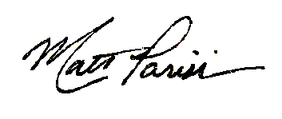

Matt Parisi
Treasurer, Class of 2015

